Sentiment Analysis for Marketing and Development

SHYAM.S : 510521104045

PHASE 4: DEVELOPMENT PROJECT



There are several companies claiming to offer AI-based [sentiment analysis](https://emerj.com/partner-content/crowdsourced-sentiment-analysis-applications-social-media-customer-service/) solutions to companies, specifically their [marketing](https://emerj.com/ai-sector-overviews/artificial-intelligence-in-marketing-and-advertising-5-examples-of-real-traction/) and product development departments. In fact, some of the largest tech companies are offering these solutions to medium and large enterprises. We found these solutions are intended to help companies with at least one of the following business problems:

* Fitting digital influencers to a brand
* Voice of the customer analysis
* Reporting on what prospects think of a marketing campaign

**What Marketers and Business Leaders Should Know:**

Sentiment analysis is a capability of [natural language processing](https://emerj.com/ai-sector-overviews/natural-language-processing-business-applications/), a kind of [artificial intelligence](https://emerj.com/ai-glossary-terms/what-is-artificial-intelligence-an-informed-definition/). It could allow companies to search social media, the general web, and their backlog of [customer support](https://emerj.com/ai-sector-overviews/artificial-intelligence-customer-service-current-future-applications/) tickets for what their prospects and customers think about their brand and products. This can in turn allow the company to create advertisements and products that their prospects and customers will like, thus increasing the conversion rates of marketing campaigns.

We were surprised to find that some of the largest tech companies are offering sentiment analysis solutions, including Amazon, Microsoft, and IBM. Although Microsoft isn’t known for AI the way Amazon, Google, and Facebook are, they are still considerably more trustworthy when it comes to AI than many startups that claim to offer AI solutions without any data science talent to back it up.

Meltwater also seems to have several data scientists at their company, although it should be noted that many of their data scientists were hired this year. This includes their Head of Data Science Product, [Jack Clearman](https://www.linkedin.com/in/jackclearman/). He holds a PhD in Experimental Psychology from the University of Cambridge, which he earned in 2017. It doesn’t seem as though he has much business experience working with data or machine learning, although his education is of course a statistical field.

Clearman meets our standard for data science talent at companies claiming to offer AI solutions, but his recent hire in addition to those of the data scientists under him seem to suggest that Meltwater is only recently forraying into AI. There’s nothing wrong with this, but we believe business leaders should know about the challenges they may face when dealing with established firms that are claiming to be doing AI.

Many large enterprises will hire data science talent just to say that they are doing AI in order to appear to be on the cutting-edge. Oftentimes, these data scientists don’t work on anything for many months after their initial hire because the company that hired them only did so to use the buzzword. We are in no way saying this is the case for Meltwater, but it very well could be. We cannot verify this on their LinkedIn page.

Generally, we like to see data scientists at companies who have been there since the company’s inception or at least very early on, as is the case for [companies that are predicated on AI](https://emerj.com/ai-executive-guides/ai-advantage-tech-giants-amazon-facebook-google/), such as Google, Facebook, and Amazon.

That said, Meltwater does in fact employ several data scientists with the requisite academic background. Many hold at least a Master’s in computer science or a statistical field. Our criteria for vetting companies claiming to offer AI solutions are laid out in our in-depth executive guide, [*How to Cut Through the Artificial Intelligence Hype – Three Simple “Rules of* Thumb.”](https://emerj.com/ai-executive-guides/how-to-cut-through-the-artificial-intelligence-hype/)

Amazon, IBM, Microsoft, and Meltwater: it’s rare for us to find a sector, industry, or business problem in which the top companies claiming to do AI are such large tech firms. This bodes well for business leaders and marketers looking to use sentiment analysis software for understanding their customers better, allowing them to create more [tailored marketing campaigns](https://emerj.com/ai-sector-overviews/personalized-marketing-with-ai/) and establish better product-market fit.

**Fitting Digital Influencers to a Brand:**

**IBM:**

IBM offers [Watson Tone Analyzer](https://www.ibm.com/watson/services/tone-analyzer/), which it claims can help marketers in all industries gain an understanding of how people see their brand using Sentiment Analysis.

IBM claims marketers can integrate the software into the client company’s social media accounts or other places that receive customer feedback.

We can infer the machine learning model behind the software was trained on hundreds of thousands of text snippets from social media involving customer experiences with brands and products. This text data would have been labeled as a negative or positive experience, and also by the brand or product in question. The labeled text data would then be run through the software’s machine learning algorithm. This would have trained the algorithm to discern the chains of text that, to the human brain, might be interpreted as a positive or negative sentiment as displayed in a social media post.

Tone Analyzer would then be able to run through public social media posts, and the algorithm behind the software would then be able to determine which product or brand is being talked about and the sentiment behind each post. The system then provides insights by listing the subject and tone of all uploaded social media posts. This would allow the client company to get a sense of how their customers see them.

Unfortunately, we could not find a video demonstrating how Tone Analyzer works.

IBM [claims to have helped](https://www.ibm.com/case-studies/influential) Influential match digital influencers to brands for marketing campaigns. Influential integrated IBM’s software into its network of influencers in order to observe their social media presence. According to the case study, Influential was able to examine 47 characteristics of their influencers’ personalities. This information helps to determine whether an influencer’s personality will match that of the brand they are advertising.

IBM also lists LegalMation and Max Kelsen as some of their past clients.

**Voice of the Customer Analysis:**

**Amazon:**

Amazon offers a software called [Amazon Comprehend](https://aws.amazon.com/comprehend/), which it claims can help marketers in numerous sectors analyze customer social media data and find out how people feel about their brand using sentiment analysis. Amazon claims marketers can use the software to determine which products their prospective customers are talking about on social media.

We can infer the machine learning model behind the software was trained on hundreds of thousands of snippets from customer reviews, social media posts, and emails, all of which would involve opinions on products and brands the customers have used. This text data would have been labeled according to categories like “disappointed” or “satisfied,” as well as by which products are being talked about.

They would also have to be labeled by which language they were written in. The labeled text data would then be run through the software’s machine learning algorithm. This would have trained the algorithm to discern the chains of text that a person might interpret as a comment about a product as displayed in a social media post.

Amazon Comprehend could then run through social media, and the algorithm behind the software would be able to determine which products are being talked about in which languages, as well as the tone with which the products are discussed.

Amazon does not have a demonstration video on how its sentiment analysis software works. In addition, Amazon does not make available any case studies reporting success with their software.

Amazon also lists Clear View Social, In for, and Element as some of their past clients:  
  
**Microsoft Azure:**

Microsoft Azure offers a software called [Microsoft Cognitive Services](https://azure.microsoft.com/en-us/services/cognitive-services/) Text Analytics API, which it claims can help retail companies use customer feedback data to drive product development using sentiment analysis.

We can infer the machine learning model behind the software was trained on hundreds of thousands of snippets of text-based customer feedback involving consumer product and brand experiences. This text data would have been labeled as a positive or negative experience, in addition to which brands and products were discussed in the snippets of text. The labeled text data would then be run through the software’s machine learning algorithm. This would have trained the algorithm to discern the chains of text that, to the human brain, might be interpreted as a written expression of a customer’s experience with a brand or product as displayed in the form of an email, social media post, or customer review.

Cognitive Services Text Analytics API could then be run across various social media platforms, and the algorithm behind the software would then be able to determine the sentiment of each snippet of feedback, as well as what product is being spoken about. The system then provides structure to the data so that it can be displayed with proper labels to the company. This could allow for a faster method of measuring feedback for product development.

Microsoft Azure does not have a video demonstrating how Microsoft Cognitive Services works, and it also does not make available any case studies reporting success with their Cognitive Services Text Analytics API.

Microsoft Azure also lists Toho and Allianz as some of its past clients that have used the Cognitive Services  Text Analytics API software.

**Reporting on What Prospects Think of a Marketing Campaign:**

**Melt water:**

[Meltwater](https://www.meltwater.com/za/) offers a name sake software which it claims can help retail companies report on brand awareness on social media and ROI from digital marketing initiatives using natural language processing-based sentiment analysis.

We can infer the machine learning model behind the software was trained on thousands of social media data points from customers, such as a tweet, Facebook status, or Instagram post. These would have involved products, brands, and key phrases from the company’s current marketing initiatives. This text data would have been labeled as positive or negative sentiment, as well as by which product or initiative was discussed in the tweet or status. The labeled text data would then be run through the software’s machine learning algorithm. This would have trained the algorithm to”understand” the chains of text that a person might interpret as a positive or negative experience with a brand as displayed in a social media post.

The client company could then deploy Meltwater’s software onto various social media platforms, and the algorithm behind the software would then be able to determine the sentiment behind the posts, as well as which brands or products are being discussed in each of them. The system then provides data on which aspects of the marketing campaign customers are talking about the most. This could help businesses determine how well a digital marketing initiative is working by showing how customers are interacting with it.

Meltwater does not have a demonstration video on how its software works.

Meltwater [claims to have helped](https://www.meltwater.com/za/case-study/vans/) Vans prove the performance of its digital marketing initiatives and, in turn, improve communication at the company. Vans used Meltwater’s software to analyze social media data involving their online advertisements. The marketing department of the company needed to show proof that their digital marketing initiatives were producing ROI in order to gain a better digital advertising budget from upper management. According to the case study, Vans was able to produce reports that showed how they were gaining ROI from their digital marketing initiatives. This helped the company provide a sufficient budget to bandwidth for digital marketing.

Meltwater also lists AutoTrader.co.ca, Fashion Revolution, and Stats SA as some of their past clients.

Jack Clearman is Head of Data Science Product at Meltwater. He holds a PhD in Experimental Psychology from the University of Cambridge. He joined the compan in June of 2018. [Tim Budden](https://www.linkedin.com/in/tim-budden-82b5392/) is the Senior Director of Data Science at Meltwater. He holds a DPhil, the Oxford equivalent of a PhD, from Oxford University.

**Sentiment Analysis Methodology:**

Below is the process flow of a generic Sentiment Analysis process

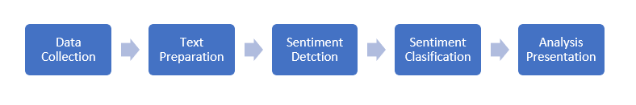

1. **Data collection:**

As the Sentiment Analysis leverages vast user-generated content, the raw data from various data sources such as Social Media, Blogs, Discussion Boards, Review Sites, and E-Commerce are collected and stored in a Data Lake. At this point, the data is highly disorganized and unstructured.

1. **Text preparation:**

This phase involves the cleaning of the extracted data and prepares it for further analysis. For efficient analysis, irrelevant information such as noise, non-contextual content, metadata, and stop words gets identified and removed

1. **Sentiment Detection:**

Before leading to the next phase, it’s essential to filter the data further for efficient analysis. In this process, all the textual sentences in the dataset get tested for subjectivity. Only the sentences with subjective expressions are retained in the data set for further analysis, whereas the rest are discarded.

1. **Sentiment Classification:**

In this phase, the subjective text data gets classified into various sentiment classifications. After sentiment classification, the polarity of the sentiment is detected and determined whether the text expresses positive, negative, or neutral emotion. Broadly, there are three types of sentiment classification algorithms.

* **ML-Based:** This method uses Machine Learning algorithms, which leverages prediction models extensively trained using pre-existing labelled data.
* **Lexicon-Based:** This approach uses a dictionary of words in which each word gets mapped with **its** emotional polarity and sentiment strength. Then, the dictionary is matched with the data to calculate the overall polarity score.
* **Hybrid:** This method leverages the best of both above. It uses Lexicon-Based algorithms for training the prediction model, where Lexicon is proven to be more efficient. The same prediction models are used to analyze the data using ML for a quicker turnaround.

1. **Analysis Presentation:**

Conventionally, the analysis insights were published as standalone reports and graphs. But with the growth in technology to process a large amount of data in real-time, interactive dashboards with detailed data visualization features are currently used. 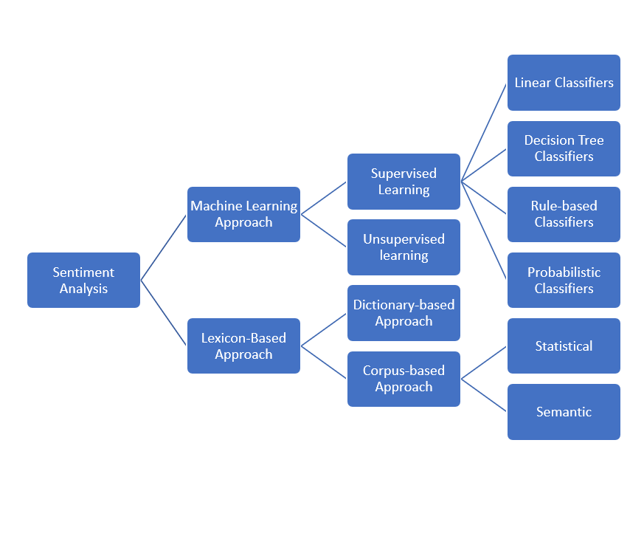

**Application of Sentiment Analysis in Market Research:**

Sentiment Analysis not only helps businesses monitor their customers’ perception of their brand but also provides valuable market intelligence on the complete ecosystem. The following are some of the secondary market research use cases of Sentiment Analysis.

* **Competitor Analysis :**

Sentiment Analysis not only provides insights about your online reputation but also allows for an understanding of what customers in the target segment think of your competitors. These deep insights help in bridging the gaps in products and services to resonate with the target audience and also aid businesses in staying ahead of the competition.

* **Product Optimization:**

With the development of deep-dive analysis algorithms, it is possible to understand not only the sentiment of the customers towards a product but also the factors, features, and attributes.. Such insights help businesses optimize their offerings and make it attractive to their target segment.

* **Customer Experience:**

An immense amount of customer data such as chat transcripts, voice recordings, and e-mails get generated while customers interact with customer support. Measuring the customers’ reactions in these interactions would give us a clear picture of their level of satisfaction, and also reflects the performance of the support teams.